HIRE YOUTUBE INFLUENCERS APPLICATION

Project Title : YouTek

Group Name : The Iconic Crew

Rajeshwari Siddipeta : 700734100

Chandrika Yenugula : 700734544

Yaswanth Machavarapu : 700733080

Niveditha Panguluri : 700734527

**Project Description :**

**Youtek** is a web or mobile based application that acts as platform for clients/companies to hire youtubers for their products brand promotion. The main purpose or objective of this system is to find out top YouTube influencer’s details and particular channel details as well as views etc.

This Application is developed over HTML and JS. Application is hosted over S3 server. Application will integrate to backend system via API. The API will be created & published using API GW. API Gateway will further forward request towards lambda. AWS Lambda is a serverless, event-driven compute service that lets you run code to virtually communicate with database, log monitoring. The application uses AWS RDS as an database instance -MYSQL.

Features:

This application has various features:

* Sign-up
* Login (admin & User)
* Search for category
* Displays list of youtubers involved with that particular category
* Select Youtuber
* View Youtuber details
* Contact Youtuber
* Logout

**Architecture Diagram :**

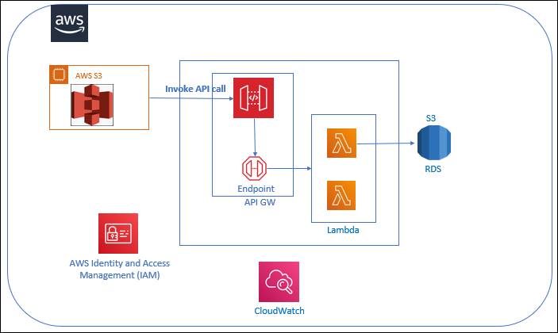

**Services Used:**

AWS API GW – API Gateway is a gateway made up of Lambda functions that combine to form a serverless learning management system. API Gateway is a fully managed service that allows developers to easily publish, maintain, monitor, and secure APIs of any size.

AWS Lambda - AWS Lambda is a serverless, event-driven compute service that allows you to run code for almost any type of application or backend service without the need for server provisioning or management.

AWS CloudWatch - Logs, metrics, and events are used by CloudWatch to collect monitoring

AWS IAM - AWS Identity and Access Management (IAM) is a web service that controls access to AWS resources securely.

AWS RDS - Amazon RDS (Amazon Relational Database Service) is a collection of managed services that make it simple to set up, run, and scale databases in the cloud.

AWS S3- An object storage service that offers industry-leading scalability, data availability, security, and performance

AWS SES- Simple Email Service is an email platform that provides an easy , flexible and cost-effective way to send and receive email using your own email addresses.

**AWS RDS:**

Amazon Relational Database Service (Amazon RDS) is a cloud-based web service that makes it easy to configure, run, and scale Relational database. Amazon RDS reduces the administration of relational database automation. For high availability and failover, Amazon RDS creates several instances like PostgreSQL, MySQL, MariaDB, Oracle, SQL Server, and Amazon Aurora. Amazon RDS stores data as tables, records, and fields. Values ​​from one table can be related to values ​​from another table surface. Relations are an important part of relational databases. Transactional Analytical data is often stored in relational databases. Transactional databases benefit from the stability and reliability offered by relational databases.

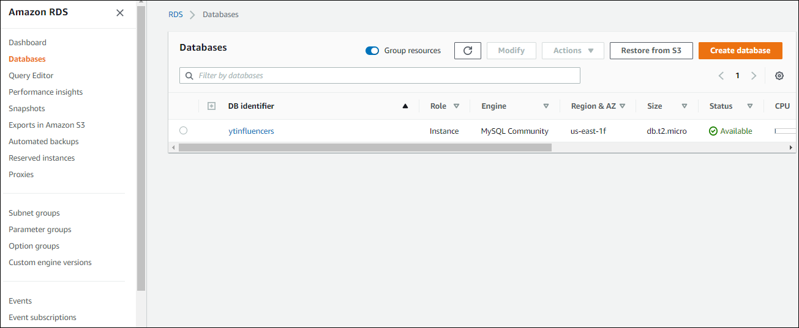

* TO create database, click on create database and then select Mysql and

provide username and password.

* View DB instance.

* Add VPC security groups by editing inbound rules.

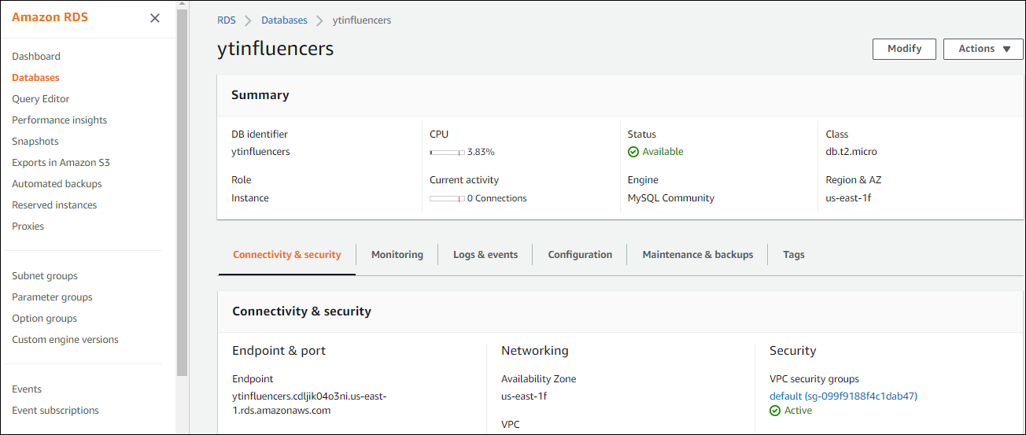

* An end point and port will be created in this step.

**AWS API GW:**

Amazon API Gateway is a fully managed service that makes it easy for developers to build, publish, maintain, monitor, and secure APIs of any size. API Gateway can be used to build RESTful APIs and WebSocket APIs that support real-time two-way communication applications. API Gateway works with container, serverless, and web applications. API Gateway handles all aspects of accepting and processing hundreds of thousands of concurrent API calls, such as traffic management, CORS support, authorization and access control, API blocking, monitoring, and versioning.

For each API call in lambda we create a API Gateway.

* Click on create API .

* Now select REST API and build.

* Select the API.

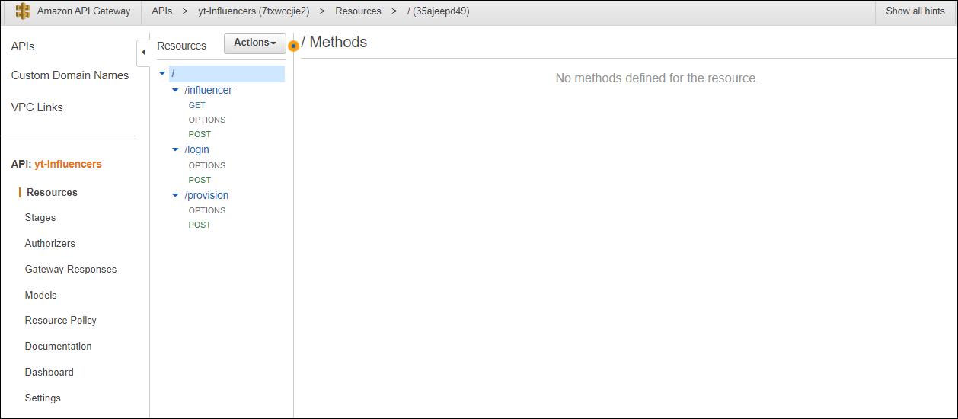

* Click on actions and create method and resource.

**AWS Lambda:**

AWS Lambda is serverless, event-driven compute service that lets you run code in about any type of backend application or service that does not require a server procurement or management. Just write your code and download it as a .zip file or a container image . Response code Automate requests of any size, from a dozen to hundreds per day and thousands per second.

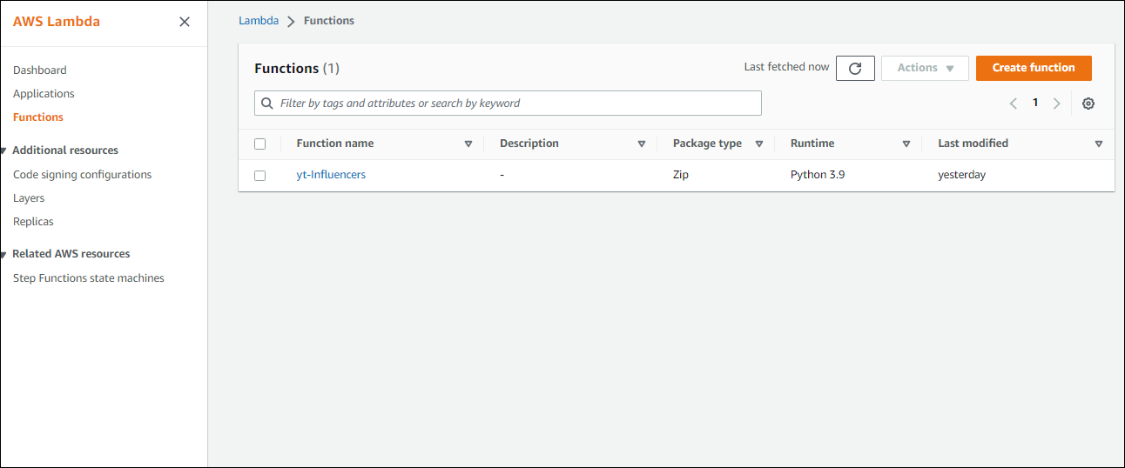

* In this step, we create a function in AWS Lambda.

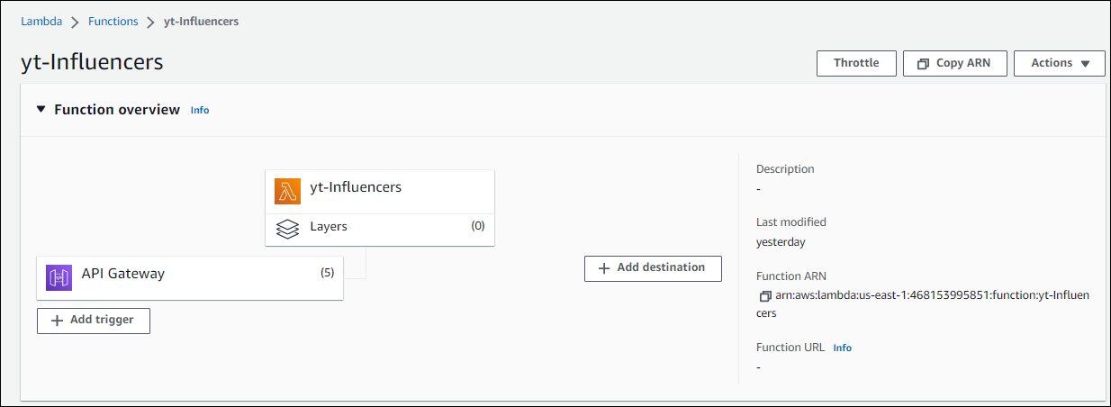

* In this step, we add a trigger which is API Gateway.

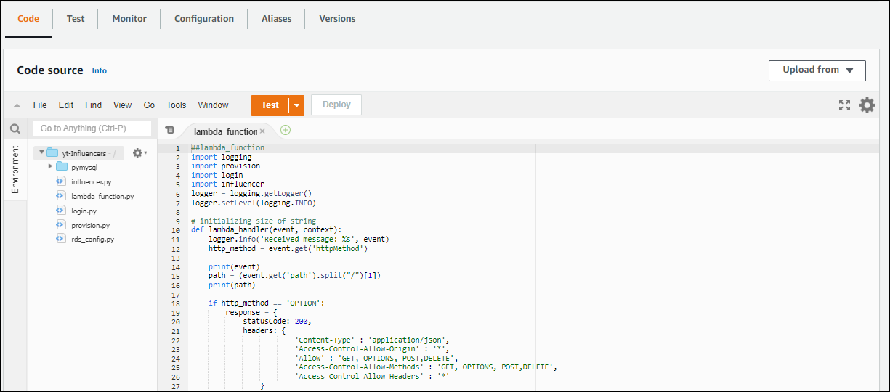

* On the console we write the backend code and deploy.

* Here we will provide the endpoint and database properties in rds_config.py.

**AWS CloudWatch:**

Amazon CloudWatch is an observability and monitoring service designed for DevOps engineers, developers, site reliability engineers (SREs), IT managers, and product owners.

CloudWatch provides actionable data and insights to help you monitor applications, react to changes in system performance, and optimize resource utilization.

CloudWatch uses logs, statistics, and events to collect monitoring and operational data You get full visibility into AWS resources, applications, and services running on AWS and on-premises, and a unified view of their status. To keep your applications running smoothly, you can use CloudWatch to detect abnormal behavior in your environment, set alarms, view logs and statistics side-by-side, perform automated actions, troubleshoot issues, and discover insights.

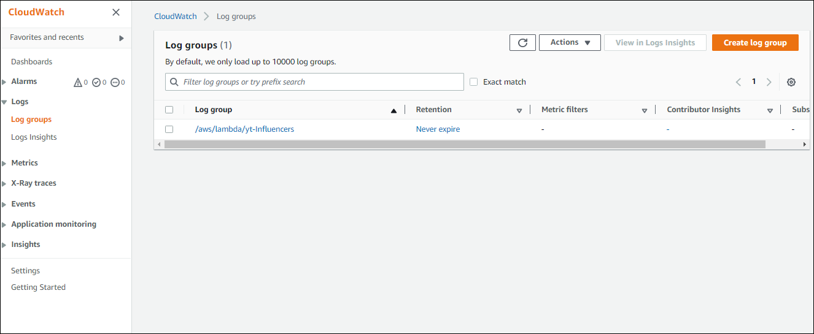

* From the lambda console, click on monitor to view logs.

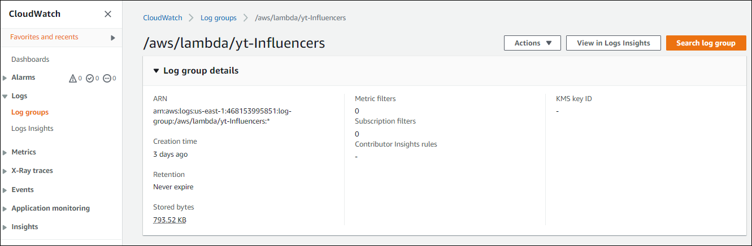

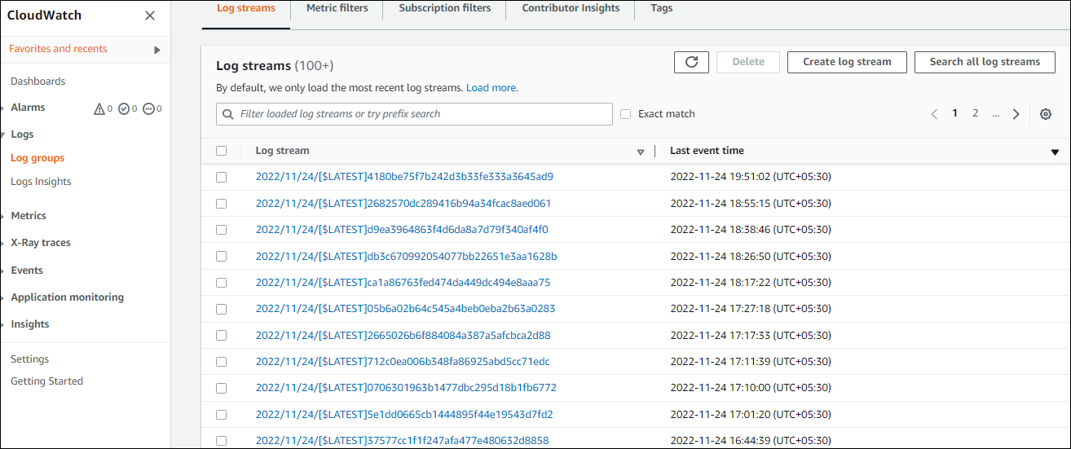

* Now, click on individual logs to view the detailed description.

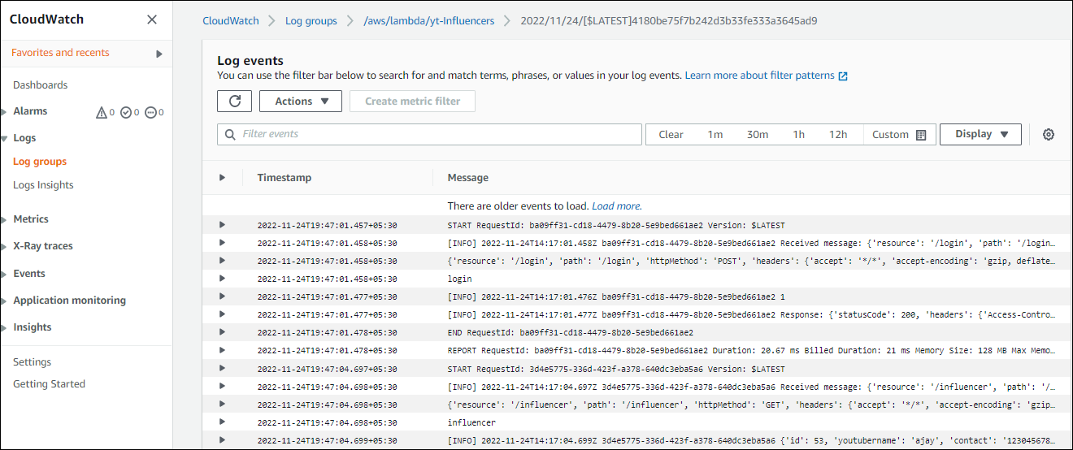

* View the detailed description of each log.

**AWS SES (Simple Email Service) :**

AWS services to improve email deliverability and provide more control over your email

campaigns. For example, you can integrate applications running on Amazon Elastic bean

with AWS SES to send emails. This application contains email service, in order to send a confirmation email to that particular user. Before sending the email, the user email needs to be verified in AWS SES. To do that, we need to create identity and provide that particular user email address. The figure contains the list of user’s email address which has already been verified.

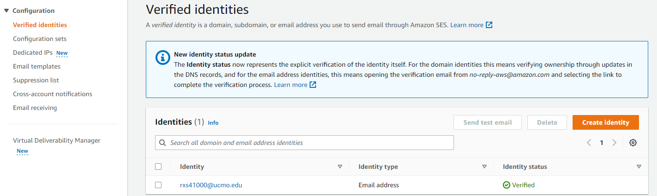

* Go to verified identities Click on create identity.

* Give the email address to whom the mail should be sent and then click on create identity.

**AWS IAM:**

AWS Identity and Access Management (IAM) is a web service used to control access to AWS resources. The IAM workflow consists of the following elements:

* A principal is an entity that can perform actions on AWS resources. user, role or application anyone can be a director. The process of confirming that the identity of the principal attempting to access the AWS product is called validation. The principal must provide the necessary credentials or an authentication key.
* Requirements: School Principal sends a request to AWS specifying the action to perform and the resources to use. one set Can perform actions on resources associated with your AWS account.
* Permission: By default, all resources are denied. IAM allows only one ask if the policy allows all its components. IAM authorizes the request only if all parts of the request are authorized by match politics. Once the request is validated and authorized, AWS approves

* Click on Roles and then create role for Lambda, API Gateway and RDS services.

* Add policy for Lambda.

**AWS S3:**

Amazon S3 is an object that provides industry-leading scalability, data availability, safety, and performance Customers of all sizes can use Amazon S3 Industries that store and secure any amount of data for a variety of use cases, including data lakes, websites, mobile apps, backup and restore, Archiving, enterprise applications, IoT devices, and big data analytics Amazon S3 includes features that let you optimize, organize, and Configure data access to suit your business, organization, and Compliance requirements.

* Click on create bucket.

* Upload the files such as html, css, js and Images here.

* On permissions tab, add policy.

* Then click on edit static website hosting, in properties tab

* Enable static website hosting here and end point will be created and that will be our application url.

**User Interface:**

* Client/User can login here.

* Search and select a category.

* Click on Submit.

* Select the Youtuber

* View the info and contact the youtuber by clicking contact button.